Life Changing Transplant Foundation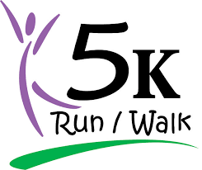

Hosted by Life Changing Transplant Foundation, our goal is to educate the community on the importance of organ donation, while financially supporting NC pre & post-transplant patients & their family members.

- Walk or run to raise funds for patients & family members by forming a team
- Hear testimonies from transplant patients
- Enjoy food and fun for the whole family

Life Changing Transplant Foundation
Annual 5k Run/Walk for Life
Saturday, September 15, 2018
Knightdale Station Park
810 N First St.
Knightdale, NC 27545
Registration & Check In: 8:00 am
Opening Ceremony: 8:40 am
Run/Walk Starts at 9:00 am

Early registration fee $20 ends August 26, 2018
Late fee $25

Learn more, register your team and start fundraising today!
Contact: (919) 771-7576 or email lifechangingtransplant@yahoo.com

